Chapter 6: Muscles
- OVERVIEW OF MUSCLES
- Muscle Types
- Skeletal Muscle

- Gross Anatomy
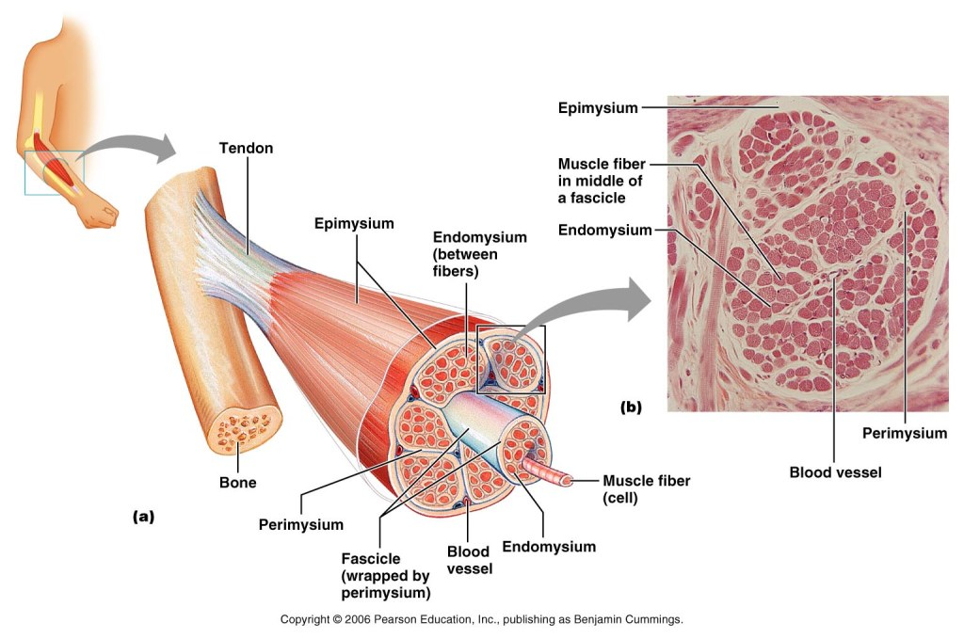

- Smooth Muscle
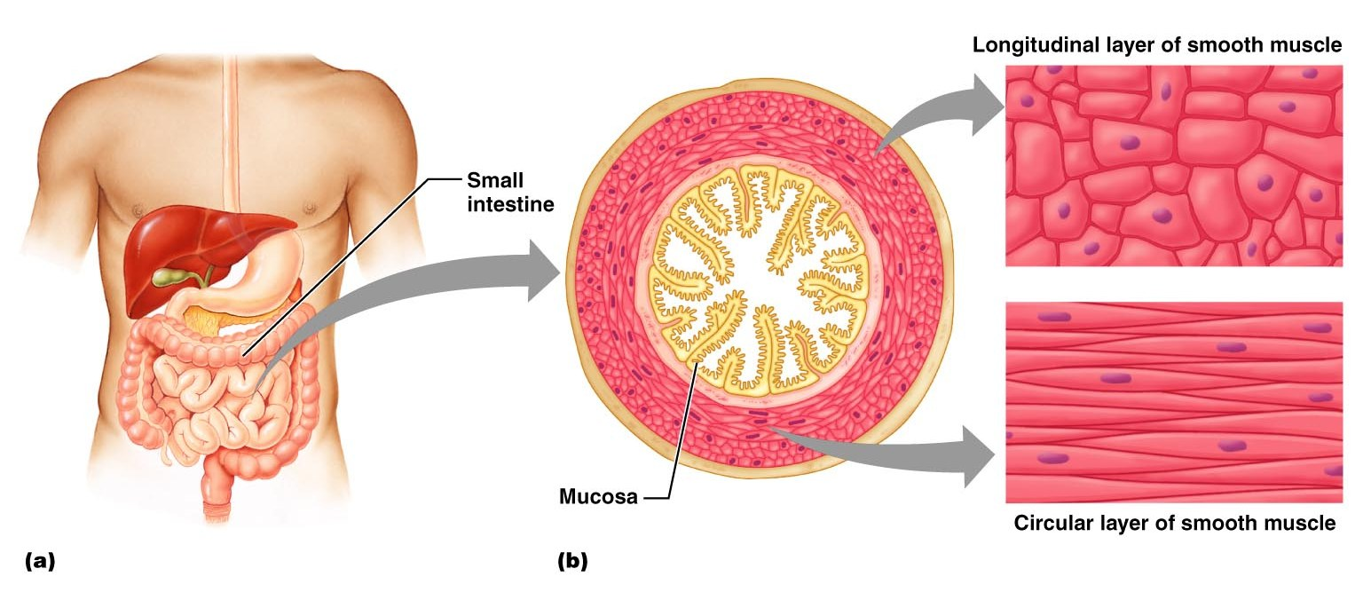
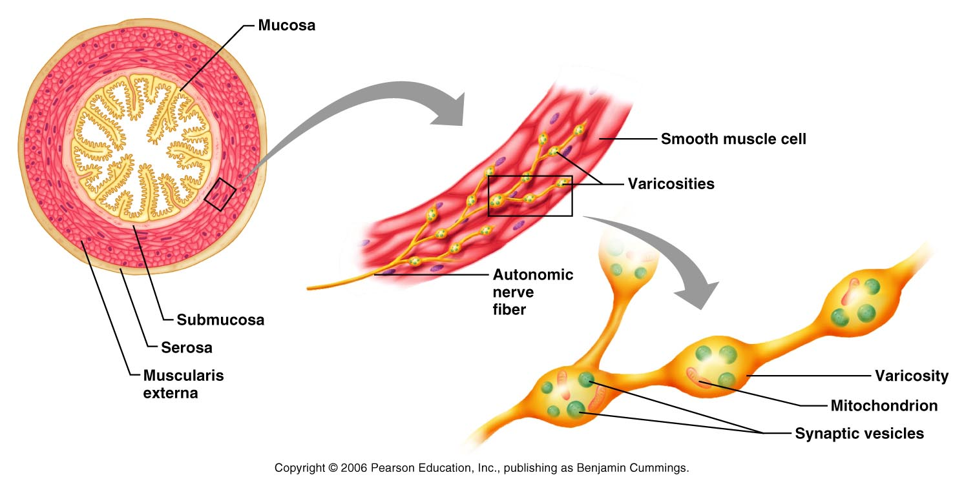

- Cardiac Muscle
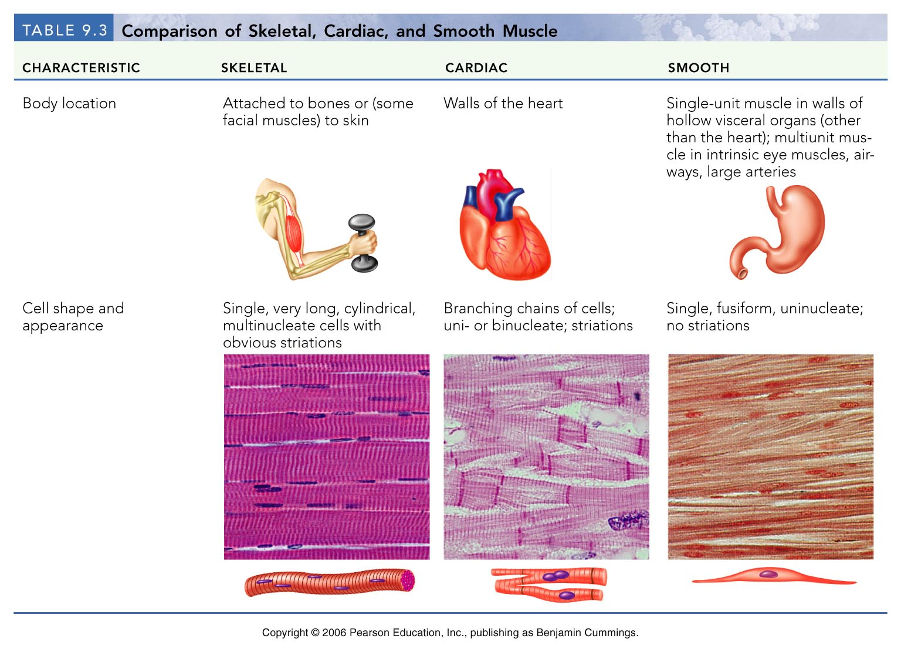

- Muscle Functions
- Producing Movement
- Maintaining Posture
- Stabilizing Joints
- Generating Heat
- MICROSCOPIC ANATOMY OF MUSCLE

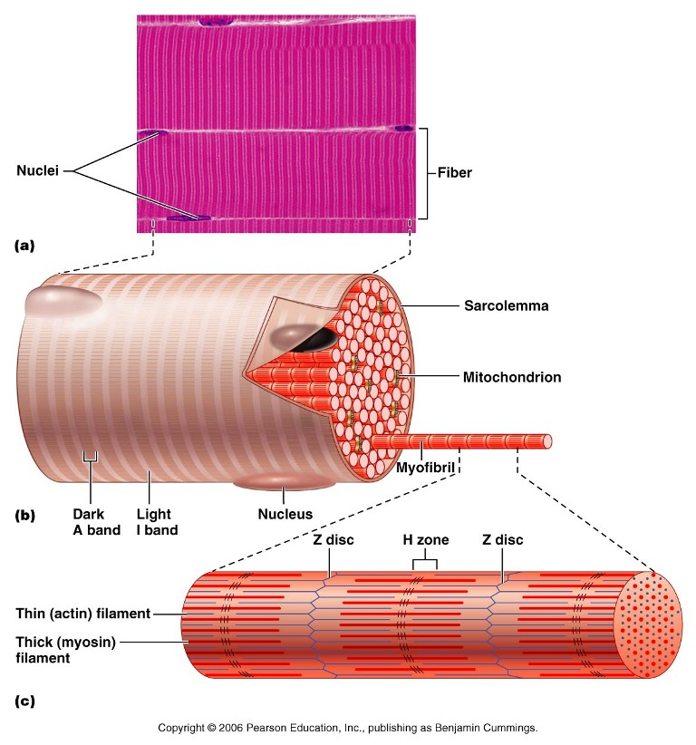
- Myofilaments

DRAW MYOFILAMENTS
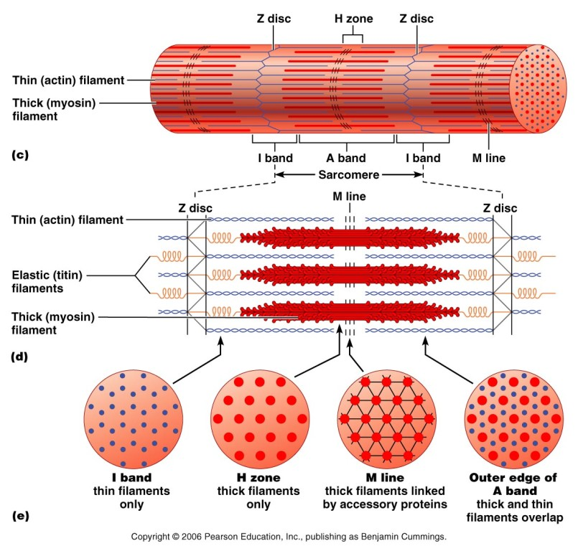

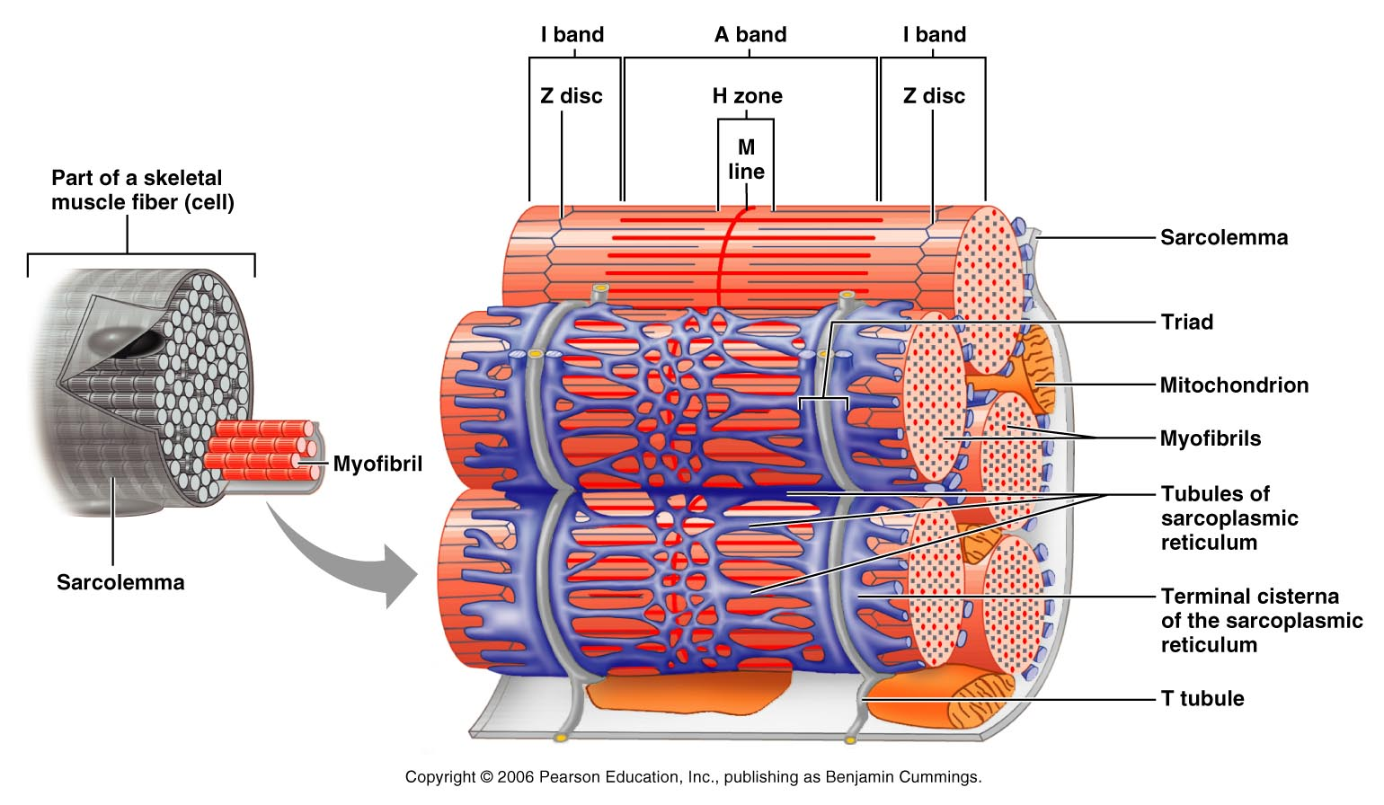
- SKELETAL MUSCLE ACTIVITY
- Stimulation and Contraction
- Nerve Stimulus & Action Potential
- Motor Unit

- Neuromuscular Junction

- Generation of the Action Potential

- Excitation-Contraction Coupling
- Cross Bridge Attachment
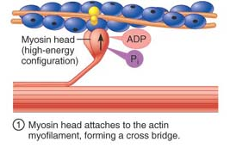
- Power Stroke

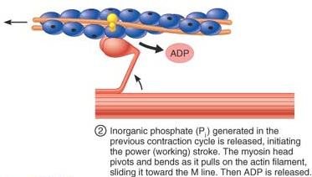
- Cross Bridge Detachment

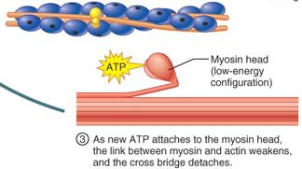
- Cocking of Myosin Head
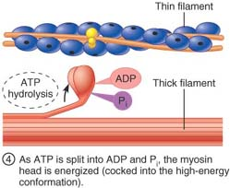

- Role of Ca²⁺ in Contraction
OVERVIEW OF MUSCLE CONTRACTION

- Rigor Mortis
- CONTRACTION OF THE WHOLE MUSCLE
- Graded Responses
- Muscle Response to Increasingly Rapid Stimulation

- Muscle Response to Stronger Stimuli
- Energy for Contraction

- Phosphorylation of ADP by Creatine Phosphate
- Aerobic Respiration
- Anerobic Glycolysis

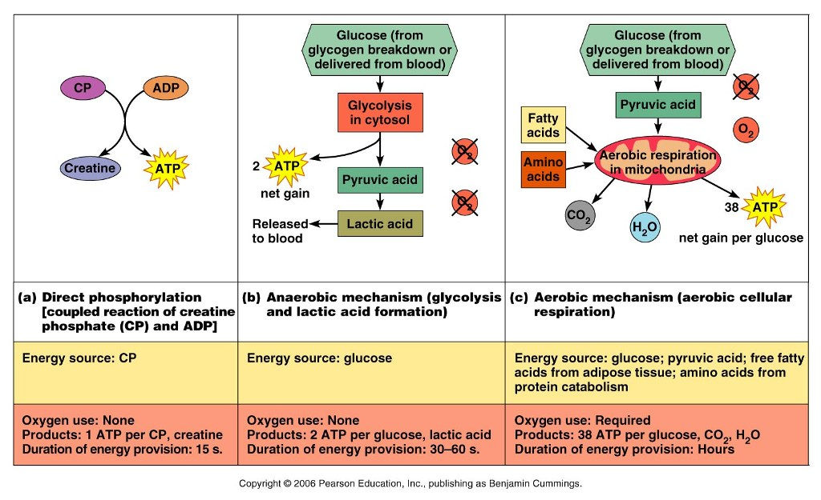
- Fatigue and O₂ Debt
- Types of Contractions

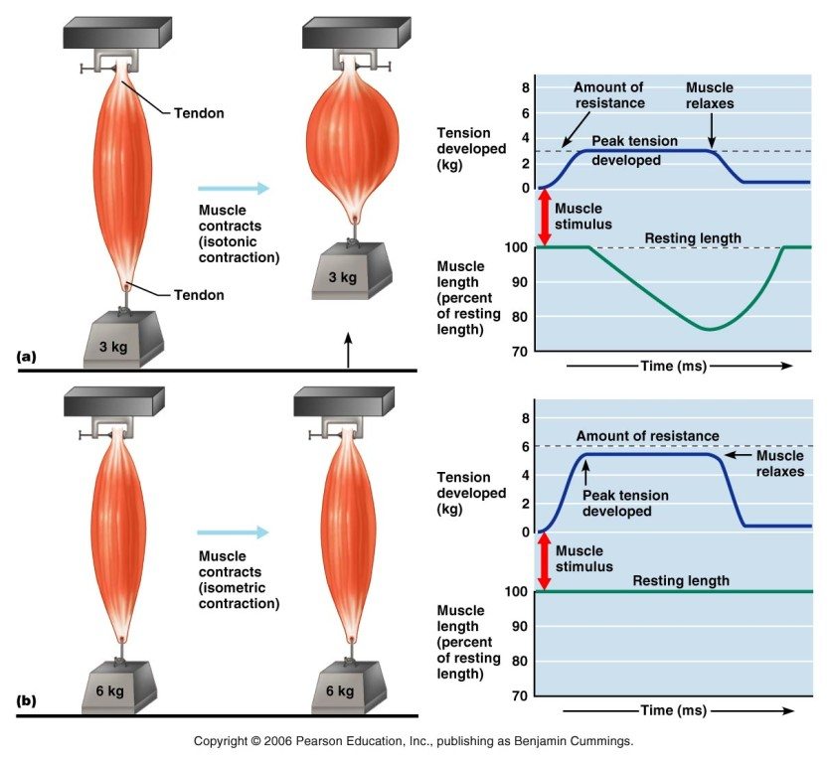
- Muscle Tone
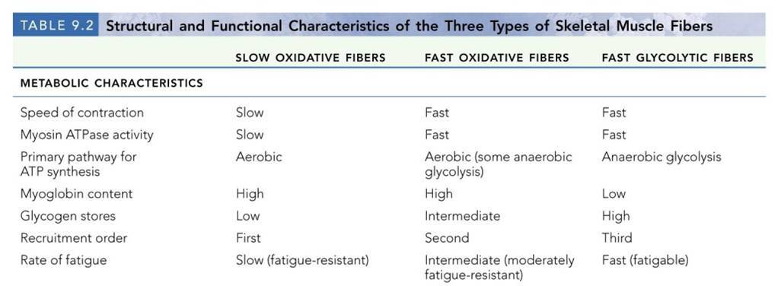

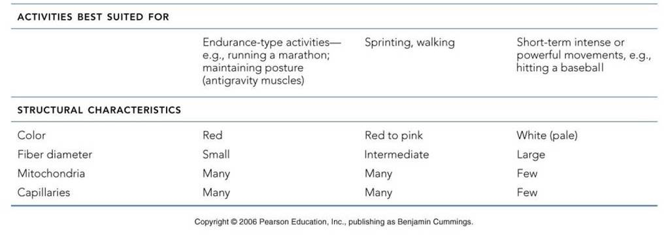
- MUSCLE MOVEMENTS, TYPES, & NAMES

